**Team: 😐**

**1.mohamed mosad fraouk**

**2.omar Ayman Mohamed**

**3.Ali taha Naser**

**4.Mohamed Abdalgafar salem Badawy**

**5.Ahmed Sherif Ramdan**

***The Documentation of University Management System.***

***In this documentation we are going to talk about the faculty Management system in the first we will talk about E.R.D.***

***The E.R.D is a diagram in which the programmer use, to know how the system will be and how he handles the project and make the map that the system will depend on it.***

***In this E.R.and foreign keys and all of them are connected.***

***So, the E.R.D is the base that the programmer builds on.***

***Then we are going to talk about the second most important component among these components which is the Mapping.***

***The Mapping is a set of tables that clarify the E.R.D and it is easier to the user to read it.***

***And if you look in the figure front you will see that the 3 tables are connected to each other by foreign keys and primary keys and in the figure front the foreign key in 1st table pointing to primary key in the second table and the foreign key in the 2nd is pointing to the foreign key in the third table the mapping is also a way to make the database in easier way.***

***After that it comes the login G.U.I that consider a gate to the main G.U.I so in the login G.U.I the user just complete the login details like write his username and the password to login to the main project and after filling them just click on the button LOGIN to go to the next G.U.I but if he wants to cancel the operation, he just need to click on the cancel button like the figure front.***

***after that it comes the main G.U.I and the base of the project which is the universty management system.***

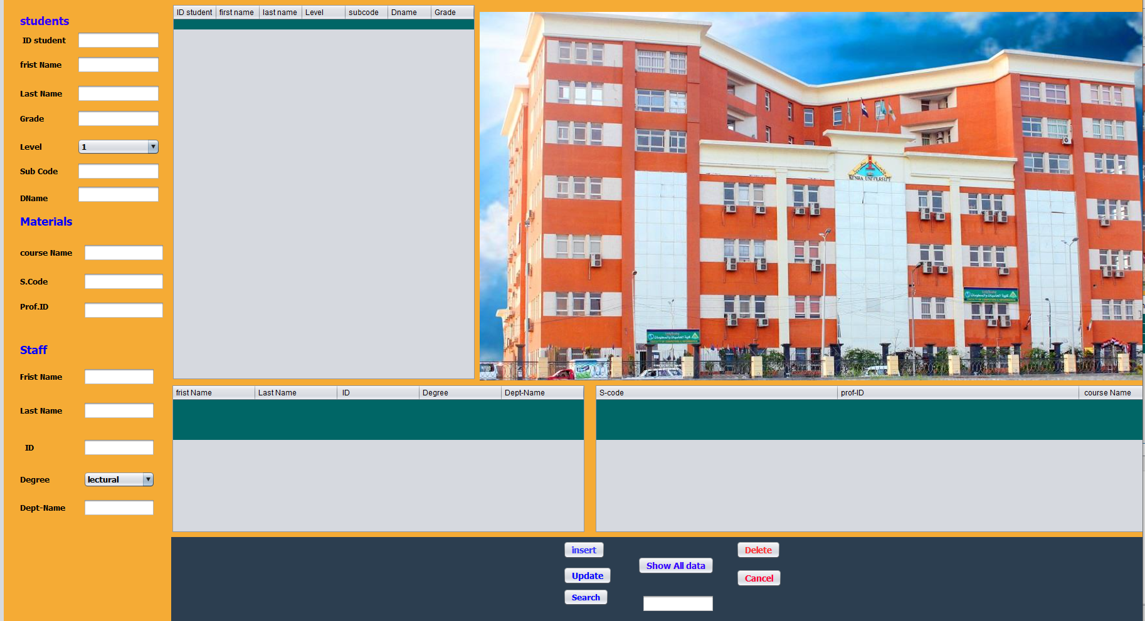

***In this page after the admin or user click login this G.U.I will be shown as the user need to fill this information to be saved in the database as important information and as shown in the figure above if the manager need to search for some students in this university he just need to fill the student information and give him the materials and insert it in the database , and if he need to search for the staff he just need to complete it’s information and click on insert to be saved in the database and if he need to change some information just click on update and go to the information and update it and it will automatically save in the database , if the user need to search for information about someone just type his ID and his information will be shown in the G.U.I and know what he want to know like his name and the material and his grade and his level, if the use need to know all the data of the database just click on the “show all data button” and all the database information will be shown in front of him, and if the user need to delete information about someone all he just do is click delete button and delete the selected one from the database and after that he will be deleted completely from database, “cancel” button : it’s simply after clicking on it the system will shut down and will get out from the project.***

**The end for progect**

**#Thanks**